Forms Experts Program

Domain Name: Cancellation Notice

Document Control Information

Document Information

|  |  |
| --- | --- |
| Document Name | Forms Experts Output_ Cancellation Notice |
| Document Author | Anukriti Singh |
| Document Version | 1.0 |
| Date Released | MM/DD/YYYY |

Document Edit History

| Version | Date | Additions/Modifications | Prepared/Revised by |
| --- | --- | --- | --- |
| 1.0 | MM/DD/YYYY | Initial version | Anukriti Singh |
|  |  |  |  |
|  |  |  |  |
|  |  |  |  |

Table of Contents

1. Functional Domain 4

2. Business Justification 4

3. List of forms covered under the domain 4

4. Analysis of Business Requirements 5

4.1 Common Requirements 5

4.2 State-specific Requirements 6

4.3 Related Change Requests 7

5. Key Understanding of Design requirements 8

5.1 AH61XX for CL : Cancellation Notice 8

5.1.1 System/UI Impact 8

5.1.2 Impacted Stories 8

Imporatant Note: 8

5.1.3 Signature Rules 9

5.1.4 Document Content and Applicable Triggers 9

5.2 AA61DE Cancellation Notice 11

5.2.1 System/UI Impact 11

5.2.2 Impacted Stories 11

5.2.3 Signature Rules(if any) 11

5.2.4 Document Content and Applicable Triggers 12

5.2.5 Key pointers to keep in mind 12

6. References to Documents 13

1. Functional Domain

Cancellation Notice

2. Business Justification

* Cancellation Notice informs the insured that their policy is in pending cancellation. It includes the reason for cancellation and the customer service number (or UW phone number) to be contacted for assistance.
* Cancellation Notice is usually accompanied by state specific notice informing the insured about necessary state regulations.
* This form is common to auto and property products.
* There are three possible cancellation reasons that will trigger this notice.

1. Fraud and/or material misrepresentation on application (Underwriting reason)
2. Substantial increase in hazard (Underwriting reason)
3. Insured request

3. List of forms covered under the domain

| Form No. | State initials | Form Name |
| --- | --- | --- |
| AH61XX | DC, ID, KY | Cancellation Notice |
| AA61DE | DE | Cancellation Notice |
| AA61PA | PA | NOTICE OF CANCELLATION OR REFUSAL TO RENEW |

*We had written stories for CT, NJ and NY which were later reverted to CL after CR408 changes.

4. Analysis of Business Requirements

## Common Requirements

| Form No. | Form Name | Form Description and its Business Use |
| --- | --- | --- |
| AH61XX | Cancellation Notice | * This notice is generated when a policy is cancelled midterm. * There are three possible cancellation reasons that will trigger this notice.  1. **Fraud and/or material misrepresentation on application (Underwriting reason):** The notice generates when the policy is placed in Underwriting Cancellation Status; the policy cancels effective on the date provided on the notice. 2. **Substantial increase in hazard (Underwriting reason):** The notice generates when the policy is placed in Underwriting Cancellation Status; the policy cancels effective on the date provided on the notice. 3. **Insured request:** The notice is generated when the policy is cancelled. There is no pending cancellation timeframe.  * Prints via central print. * Copy of form will be placed in the e-folder and Fastlane. |

## State-specific Requirements

| Form No. | State initials | Form Name | Form Description / State Specific Deltas |
| --- | --- | --- | --- |
| AH61XX | DC | Cancellation Notice | Delta to CL :   1. State specific notices added for DC. 2. Cancellation reasons need to be clearly defined in the Free Form section |
| AH61XX | ID | Cancellation Notice | Delta to CL:   1. State specific language in state specific notices depending on the cancellation reason. |
| AH61XX | KY | Cancellation Notice | Delta to CL:   1. State Specific Notice will print depending on cancellation reason.State Notices Section is variable and will only display if the cancellation is a result of material misrepresentation or Substantial increase in hazard (Underwriting reason). |
| AA61DE | DE | Cancellation Notice | New Form:   1. State Specific Notice will print depending on cancellation reason. 2. State Notices Section- Back page section is a variable and will only display if the cancellation is a result of driving activity. |
| AA61PA | PA | NOTICE OF CANCELLATION OR REFUSAL TO RENEW | New Form:   1. Form name and number. 2. State Specific Notice will print depending on cancellation reason. 3. State Notices Section- Back page section will print only for UW reasons. |

## Related Change Requests

| CR No. | CR Name | States Impacted | CR Description and its Business Use |
| --- | --- | --- | --- |
| CR 0383 | Non Renewal and Cancellation Notice | MD, CO, DE | **Problem Statement:**  The following specific information is to be printed in the Nonrenewal and Cancellation Notices which is not captured by PAS system:   * 1. Incident/accident that caused a non-renewal or cancellation   2. Offer to Exclude Drivers based on the result of accident(s), violation history or claims experience.   3. Notice of Consumer Report Information based on result of information contained in an MVR or CLUE report   4. Underwriting Guidelines – Free form text   **Change:**  Driver Activity section should be displayed on UI when cancellation is a result of driver activity.  ‘Offer to Exclude Named Driver(s)’ check box is checked only when cancellation is a result of driver activity  If the exclusion offer is offered, the ‘Recalculated Premium’ is displayed .   * There were a number of UI and other changes due to this CR |
| CR0408 | Common Forms AH61 and AH65 | AZ, CT, CO, DE, ID, IN, KS, MD, NJ, NV, NY, OH, OK, OR, PA, SD, UT, VA, WY | **Problem Statement:**   * To add variable text to AH61XX , AH65XX forms per legal requirements * Changes to be made to CL and also the states where ever delta is to be called out   **Change:**   * AH61 will now read as “Your policy will be cancelled…” and AH65 will read as “Your policy will be nonrenewed * 880-302 will be made part of 880-306 as it details about the content of a section of the form |

5. Key Understanding of Design requirements

## AH61XX for CL : Cancellation Notice

### System/UI Impact

| Page | Yes/No | Page Section |
| --- | --- | --- |
| Forms | | No | N/A | |
| *Note: Indicate section where form will display, if applies. See Policy, Driver, and Vehicle Endorsement tabs in the Product Lookup)* | |
| Documents | | No | N/A | |
| *Note: Indicate section/s where the form will display, defaults for “yes” and “no” button, if applies* | |
| GODD | | No | N/A | |
| *Note: Indicate whether document will appear on the page from Quote and/or Policy consolidated view, also the order of where on the page if new document* | |
| Related UW Rule/Task | | No | N/A | |
| *Note: This is a general reference to the related rule, if applicable. The rule requirements will be addressed in the UW assessment* | |

### Impacted Stories

| Type | Story # *(enter story # or N/A if form doesn’t require update to state specific story. Any legacy EKM story #s within the listed combo templates should be included in the story writing analysis)* |
| --- | --- |
| Form Content & Triggers | 880-306CL Form Content and Triggers - PAS Form AH61XX |
| Documents Page | N/A |
| GODD Page | N/A |
| Forms Page | N/A |
| RFI | N/A |
| Packet/Print story | N/A |

### Imporatant Note:

880-282-Cancellation Notice - ability to require a min time for cancel when company requested

This story is written as a separate story whenever there is a delta wrt the number of days the notice is generated before Effective date of Cancellation.

### Signature Rules

N/A

### Document Content and Applicable Triggers

For stories developed before CR408 changes we had two stories: 880-302CL for triggers and 880-306CL for Contents. Now these two stories have been combined into a single story 880-306CL covers both content and triggers.

There are three possible cancellation reasons that will trigger this notice :

Fraud and/or material misrepresentation on application (Underwriting reason)

Substantial increase in hazard (Underwriting reason)

Insured request



The form is saved under FastLane/Cancellation & Rescission & Reinstatement efolder.

**880-282CL story:**

At the end of the Cancellation Notice document, we have a table which lists all state deltas for Cancellation Notice generation date and Mailing Requirements.

|  |  |  |  |  |  |  |
| --- | --- | --- | --- | --- | --- | --- |
| **State/Product** | **Cancel Notice Days in UW Period\*** | | **Cancel Notice Days Outside of UW Period\*\*** | | **UW Period** | **Regulatory Rule** |
| **SI1** | **MM2** | **SI1** | **MM2** |
| **Standard**  *All states/products follow the standard unless listed differently below.* | 21 | 21 | 21 | 21 | 60 | Within & Outside UW Period: 21 days notice + 0 days mailing |

We always need to connect with the functional team for these requirements to check that this is correctly reflected in Functional specs.

For a particular state if the regulation has that the Cancellation notice is generated less than 21 days (CL for within and outside UW period) before Effective Date of cancellation, we do not program it. This is because 21 days is still more than what the regulation requires.

But for states requiring more than 21 days, we have to follow up with SME’s and write a separate story for it.



* + 1. **Key pointers to keep in mind**
* Cancellation Notice can be generated manually in PAS.

For Cancellation due to UW reasons, we move to Cancellation Notice screen and select the reason for Cancellation as Material Misrepreasentation or Substantial Increase in Hazard.

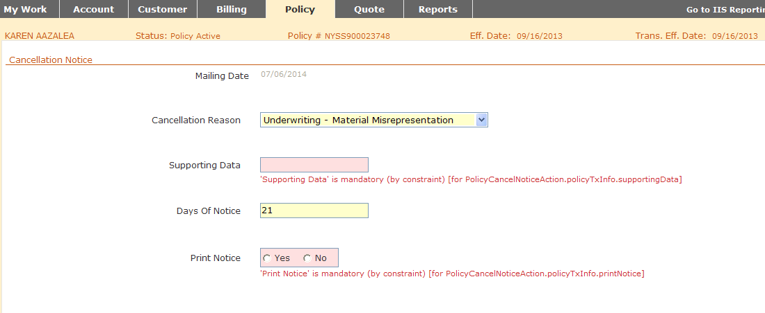

For cancellation due to Insured’s Request, we move to Cancellation screen and select the reason as ‘Insured’s Request…’.

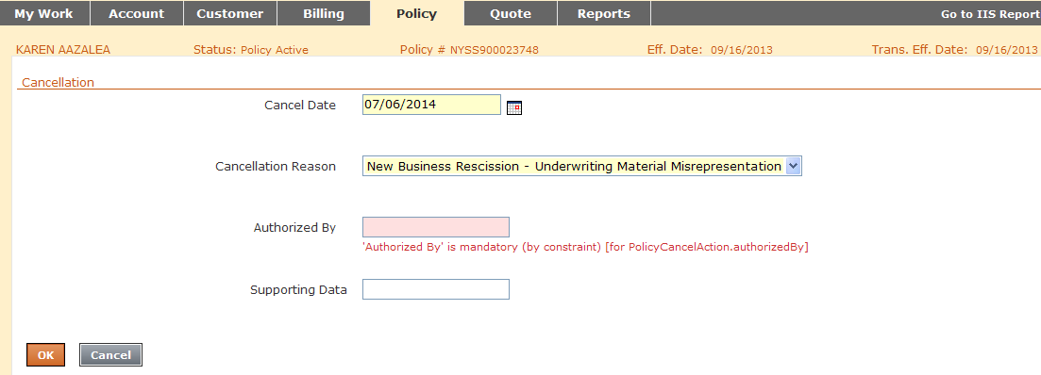

* This form is different from Non-pay cancellation notice.
* When the common form template is not used, the story ID changes to 880-309.

## AA61DE Cancellation Notice

### System/UI Impact

| Page | Yes/No | Page Section |
| --- | --- | --- |
| Forms | | No | N/A | |
| *Note: Indicate section where form will display, if applies. See Policy, Driver, and Vehicle Endorsement tabs in the Product Lookup)* | |
| Documents | | No | N/A | |
| *Note: Indicate section/s where the form will display, defaults for “yes” and “no” button, if applies* | |
| GODD | | No | N/A | |
| *Note: Indicate whether document will appear on the page from Quote and/or Policy consolidated view, also the order of where on the page if new document* | |
| Related UW Rule/Task | | No | N/A | |
| *Note: This is a general reference to the related rule, if applicable. The rule requirements will be addressed in the UW assessment* | |

### Impacted Stories

| Type | Story # *(enter story # or N/A if form doesn’t require update to state specific story. Any legacy EKM story #s within the listed combo templates should be included in the story writing analysis)* |
| --- | --- |
| Form Content & Triggers | 880-309DE Form Content and Triggers - PAS Form AA61DE |
| Documents Page | N/A |
| GODD Page | N/A |
| Forms Page | N/A |
| RFI | N/A |
| Packet/Print story | N/A |

### Signature Rules(if any)

N/A

### Document Content and Applicable Triggers

* 880-309CL Form Content and Triggers - Cancellation Notice and NOTICE OF CANCELLATION OR REFUSAL TO RENEW is a light story. We need to write new VCs leveraging 880-306CL story.
* 880-282DE Cancel Notice ability to require a min time for cancel when company requested story was written because we had a delta wrt to generation date.

|  |  |  |  |  |  |  |
| --- | --- | --- | --- | --- | --- | --- |
| **State/Product** | **Cancel Notice Days in UW Period\*** | | **Cancel Notice Days Outside of UW Period\*\*** | | **UW Period** | **Regulatory Rule** |
| **SI1** | **MM2** | **SI1** | **MM2** |
| **Standard**  *All states/products follow the standard unless listed differently below.* | 21 | 21 | 21 | 21 | 60 | Within & Outside UW Period: 21 days notice + 0 days mailing |
| **DE Auto** | 21 | 21 | 32 | 32 | 60 | Outside of intial UW period: 30 days + 2 days mailing notice is required. |

### Key pointers to keep in mind

* In AA61DE, state specific language is printed on front and back pages of the notice.
* The back page includes Offer to Exclude Driver which will appear only for UW reasons AND when cancellation is due to Driver’s activity and there are more than 1 drivers on the policy.
* Offer to Exclude Driver will not display on the UI or print on the notice when there is only 1 driver on the policy.

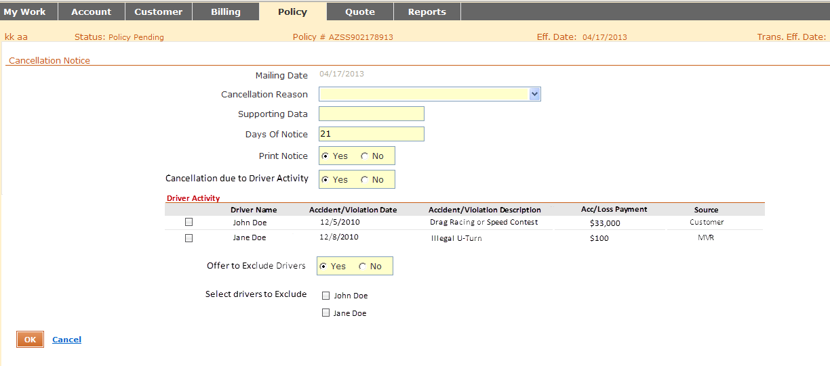

# References to Documents

   

About Deloitte

Deloitte provides audit, tax, consulting, and financial advisory services to public and private clients spanning multiple industries. With a globally connected network of member firms in 140 countries, Deloitte brings world-class capabilities and deep local expertise to help clients succeed wherever they operate. Deloitte's 165,000 professionals are committed to becoming the standard of excellence.

Deloitte's professionals are unified by a collaborative culture that fosters integrity, outstanding value to markets and clients, commitment to each other, and strength from cultural diversity. They enjoy an environment of continuous learning, challenging experiences, and enriching career opportunities. Deloitte's professionals are dedicated to strengthening corporate responsibility, building public trust, and making a positive impact in their communities.

Deloitte refers to one or more of Deloitte Touche Tohmatsu, a Swiss Verein, and its network of member firms, each of which is a legally separate and independent entity. Please see www.deloitte.com/about for a detailed description of the legal structure of Deloitte Touche Tohmatsu and its member firms. Please see <http://www.deloitte.com/us/about> for a detailed description of the legal structure of Deloitte LLP and its subsidiaries.

Internal Usage Statement

This publication is for internal distribution and use only among personnel of Deloitte Touche Tohmatsu, its member firms, and its and their affiliates. Deloitte Touche Tohmatsu, its member firms, and its and their affiliates shall not be responsible for any loss whatsoever sustained by any person who relies on this publication.

Copyright © 2013 Deloitte Development LLC. All rights reserved.

Member of Deloitte Touche Tohmatsu